GDD - M2 Combat

PROCESS STAGE: Approved
- Product Owner: David Georgeson
- Technical Lead: Avi Khetarpal
- Producer: Aiden Wallace

RACI Matrix 1
User Stories 1
Projectiles 2
Vector Projectiles 2
Projectile Collisions 2
Projectile Data Values 3
Art 3
Multishot 3
Homing Attacks 4
Characteristics 4
Art 5
Creature Attacks and AI 6
Fortress Shield 6
Equipping a Shield 6
Fortress Shield 7
Fortress Shield Characteristics 8
Art 8
UI 9
Hitscan Shots 9
Damage Calculation 9
Damage Effects 10
Tracers 10
Art 10
Combat Mode (Additional UI) 10
Post-M2 Improvements 11
Post-M2 Addition to Projectiles 11
Post-M2 Addition to Multishot 12
Post-M2 Addition to Homing 12
Post-M2 Addition to Shields 12
Post-M2 Addition to Hitscan 12
Sign Off 13

RACI Matrix

(Responsible Accountable Consulted Informed )
Deliverable | Product Owner | Tech | Art | Comm | Mktg | UX/UI | Design | QA | Prod
Projectiles | A | R | A | I | I | I | I | I | I
Multishot | A | I | I | I | I | I | R | I | I
Homing Attacks | A | R | A | I | I | I | A | I | I
Creature Attacks & AI | A | I | I | I | I | I | R | I | I
Fortress Shield | A | I | A | I | I | I | R | I | I
Hitscan Shots | A | R | I | I | I | I | I | I | I
Combat Mode | A | I | I | I | I | R | I | I | I

User Stories
- Bob wants to shoot sumthin’ reeeel gud. He grabs his Raymatic Plasmatic Ball Inducer and pulls the trigger. His weapon powers up quickly and sends a roiling ball of purple energy streaking toward his target. If it hits, his target will find out what it feels like to be on the receiving end of Radioactive plasma.
- Mary wants to one-up Bob. So she pulls out her Trionic Ionic Lightning Blaster, pulls the trigger and watches as the uniquely shaped barrel on her weapon splits the electrical energy built up within her capacitor into three small, fast ball lightnings that whip out in a pattern away from her.
- Bob, impressed, but still game to show-off, whips out his AlwaysWhomp’em kinetic energy launcher. He vaguely aims at the remaining targets and, without looking, squeezes the trigger multiple times. Each time, a small pulsating ball of energy streaks out at a target, guiding itself toward that target without Bob’s assistance.
- The last remaining target manages to squeeze off a shot at Bob and Mary. Mary scoffs and, waits patiently for the slow enemy projectile to reach them, then triggers her Fortress Shield at the last second, absorbing the incoming projectile completely.
- The remaining creature, seeing its allies destroyed and being completely ineffectual, turns to run away. Mary pulls her sidearm and hits it with a light-speed Zap-o-Matic, doing a bit of heat damage, but enough to put it down. Bob grins at Mary, they high-five and then head to the nearest pub for a beer.

Projectiles
A weapon spawns a projectile. The projectile moves along a set trajectory until it collides with something, at which point it fires an impact event that can trigger other behaviors (deal damage, create an AoE, spawn additional projectiles, etc).

The impact event needs to pass information about the impacted object so that projectiles can make decisions based on what it hit (later on, a projectile may be able to bounce when it hits terrain but explode when it hits a creature).

Vector Projectiles
Vector Projectiles travel in a straight line until they either hit something or have reached their maximum range.

Projectile Collisions
Projectiles can be set to “Ignore, Collide, or Trigger” with other things based on Collision Layer (M2 Collision Layers include: Non-Player Creatures, Players, Projectiles, Terrain, and Collidable Objects).
- Projectiles DO collide with other projectiles. You can use a large attack to annihilate incoming patterns of bullets from an attacker.
  - If two projectiles hit each other, they’re both destroyed
  - If a projectile takes damage from any other source (an AoE for instance) it is destroyed.
- In PvE, player collision shapes DO block other players’ shots, but no damage is done to the blocking player unless PvP is active.

Projectile Data Values
All Weapons that fire Projectiles have the following data:
- Projectile Speed - The speed at which the projectile flies
- Projectile Size - Larger projectiles are easier to hit and obliterate, but in turn, they can also hit and obliterate other projectiles more easily. NOTE: All projectiles are spheres.
- Damage Value: How much damage the projectile does when it hits the target.
- Damage Effect Type: Heat, Cold, Kinetic, Radiation, Corrosion, or Shock.
  - NOTE: If a projectile does negative damage, it adds Health instead of subtracting it, but still cannot exceed the character’s HealthMax.
  - Healing VFX: If a damage effect will heal a target (instead of damaging it), then there should be a visual effect added to that normal damage effect VFX so that the user can see that it is healing the target, rather than killing it. (Green sparkles within the beam or something?)
- Range - The maximum distance the weapon can fire. If Projectiles reach maximum range without impacting anything, the projectile is flagged to be able to either detonate or just simply dissipate.
- Physical projectile values such as acceleration, rotation or any other values needed to define its physics impulse
- Gravity - toggle on/off for whether gravity affects the projectile

Art
- Currently, Kinetic, Shock, and Corrosion damage effect VFX sets are complete. The other damage effects (Heat, Cold, Radiation, and Healing) need to be created.
- SFX needs to be completely redone for weapons and weapon effects.

Multishot
Multishot allows for simultaneous firing or sequential firing of projectiles with a single activation click.

When players begin the game and have a multishot-enabled weapon, they can fire multiple projectiles (determined by the weapon’s characteristics) within a flat, horizontal plane in front of them. Players always fire an odd number of projectiles so that the center projectile can always move directly away from them (straight ahead), whereas the other projectiles are evenly spaced, 10 degrees apart, to each side of the center projectile. The more projectiles there are, the wider the cone of shots becomes, with a maximum of 17 projectiles.

As the player achieves skill tree rewards, they may learn other patterns of multishot dispersal. These other patterns of multishot are created by Design. Design will create a library of these effects so they may be applied to player skill tree advancements, as well as creature attacks.

A visualization tool for multishot patterns has been created and will be used by Design for determining the characteristics needed for each pattern used: https://drive.google.com/file/d/1fNfH2J5u_1-88GpmazdwdpxfDbYEuk6k/view?usp=sharing

Details of multishot variables and details for Design to use are included in the “Direct Fire Multishot” portion of this document: https://playableworlds.atlassian.net/wiki/spaces/SR/pages/1588330497/GDD+-+Combat+5+Multishot+-+Approved+09+28+22#Direct-Fire-MultiShot

Homing Attacks
When an attack has the Homing characteristic, the player projectiles from that weapon are homing projectiles. If multiple targets are within the reticle's space, the target closest to the to the attacker is selected, if it is within the weapon's default firing range.

Characteristics
- Turning Radius: How easily a projectile adjusts towards its current target. If the turning radius is large, a projectile does not easily follow, especially if its target is mobile, so tighter turning radii are always preferable, but increase Power cost for the weapon.
- Homing Check Frequency: A variable that is designer-tunable to allow us to determine how often the homing projectile checks to see if it’s locked or not (including how often we raycast when using the painted or locked methods of homing).
- Power Cost: Derived from the turning radius and the homing mode used, the Power Cost for the Homing feature is additional to the weapon’s base Power Cost and thus increases the Focus Cost and Cooldown timer for the weapon.
- Homing Mode: Determines how a homing projectile maintains its homing target;
  - Autofire - A 90-degree cone is determined based on the position of the reticle. The closest target within that 90-degree cone is selected as the target. All projectiles fired in the attack are directed to hit that target.
    - UI: When an Autofire weapon is equipped, then the creature/player currently selected as target will be highlighted in green (or an icon applied). No green light will appear if no target is available within the targeting cone.
  - Painted - The projectile only adjusts towards the closest target the player is currently hovering over. If the player doesn’t keep the reticle within XX pixels of the target, the projectile becomes a dumbfire straight trajectory weapon again. However, if the player moves the reticle back over the target (or any target), the projectile recovers its homing characteristics and tries to again head toward the target. (NOTE: A player can fire a homing projectile without tracking and then place the reticle after firing. There is no requirement to have “tone” before firing.)
    - UI: When a Painted weapon is equipped, the creature/player currently selected as target will be highlighted in green (or an icon applied). The green highlight will not appear if no target is currently painted.
  - Locked - The player hovers the normal reticle over the target. If held over the target for XX seconds (1-2, probably), a “lock” is achieved (the reticle changes color and a tone is heard) and the missile can be fired thereafter, homing in on that target. (A locking missile may not be fired without achieving tone.) A lock is broken if the player changes weapons or if the missile can’t turn tight enough and reaches max distance traveled.
    - UI: When holding the cursor over a target, the target will be highlighted in yellow. At that time, a periodic beep will be heard as lock is being acquired. Once lock is achieved, that highlight will change to green and a steady audio tone will be heard indicating lock.
  - Multishot - If the attack with homing is also a multishot weapon, then all projectiles attempt to hit the same target.

NOTE: The type of homing for a weapon is designated at time of crafting. This is not a “firing mode” where users can toggle back and forth between the various homing options.

NOTE about “dumb-firing” of homing projectiles:
- Autofire homing missiles may not be fired without a target.
- Autofire, Painted and Locked homing projectiles may be fired without a target. In that case, the projectile acts just like a normal projectile and travels in a straight line until it hits an object. Thus, all types of homing projectiles can be fired at terrain or props as long as normal targeting conditions don’t occur.

Art
The homing projectile will twist and turn as it flies, depending upon how the target moves. To help the user identify what the projectiles are doing, the homing projectiles need to leave a persistent trail that fades after a short time.

Creature Attacks and AI
For M2, creatures should use the same exact attack options that players can use. They should also use the same VFX/SFX that the players use. Designers should be able to script those attacks per creature utilizing those same options.

Preferably, we should build the intended system for handling attacks wherein designers build a library of attack options and then individual creature scripts reference those attack options without having to rebuild each attack for each creature.

The AI for creatures should be on par with the “Pewtiful Corner” prototype. The minimum set of options the creatures should have at their disposal are:
- Select from available attacks and utilize them at anywhere between max and min ranges. This includes:
  - “Keep away” distance parameters where creatures try to stay at a certain range in order to increase survivability while using ranged attacks.
  - “Charge” attitudes where creatures try to close distance in order to use very short range attacks
- (Optionally) flee when damaged below a set health threshold.
- (Optional) aggro when an enemy is within a set radius of the individual creature or when the individual creature is damaged.
- Call for Help (option) when damaged or aggro’d so that nearby allies within a radius respond and come to their aid.
- Lairs should also be able to (optionally) Call for Help so they can rally creatures spawned by that lair, if those creatures are within a certain radius of the lair.

Fortress Shield
For M2, we are focused on creating just a single shield type (the Fortress Shield), and stripping back its functionality so that we can test gameplay and focus on basic core elements before adding all the other needed features.

Equipping a Shield
The player equips the shield on one of their four hotbar keys. Thereafter, they trigger it by hitting the appropriate number key.

Fortress Shield
A fortress shield requires a stamina cost to enable, and then individual hits can only deal marginal damage to the player beyond the shield’s threshold value. All damage subtracts from the overall strength value.
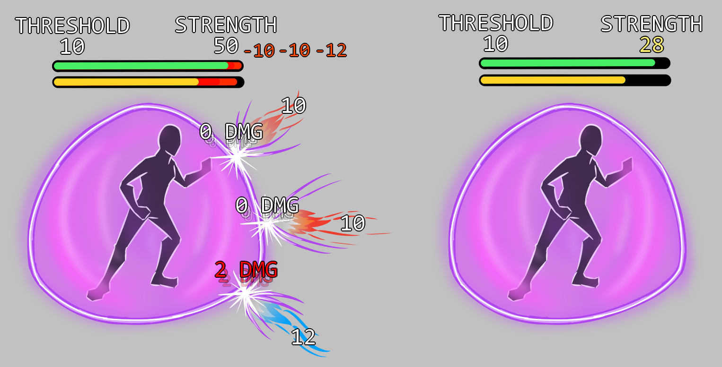
Note: In the above illustration, the capacitor’s current energy value is labeled as “strength”

A Fortress shield consumes a portion of the player’s Stamina when triggered and this powers the shield’s capacitor. The capacitor supplies energy to the shield thereafter, enabling it to stop or reduce incoming damage until that energy is depleted. However, even if not damaged, the shield itself consumes energy from the capacitor, so over time, the shield will deactivate even if not used as an active defense.

When attacks hit the shield, the shield uses energy from its capacitor to stop up to a certain maximum amount of that attack’s energy from passing through to hit the protected player. This is known as a damage threshold.
(NOTE: For initial implementation, the ratio of capacitor energy lost for each point of damage is 1:1. Later implementations may allow more efficient ratios of energy vs damage.)

The Fortress shield stays up until the capacitor’s energy is depleted. When that occurs, the shield then drops and the player is unprotected until they raise the shield again thereafter.

NOTE for clarity: If a shield has an area of effect (in other words, it’s larger than just a personal shield), then an attack may hit the shield, but still miss the player. In that case, the shield does still reduce the incoming attack’s effect, and the shield’s capacitor loses energy, but the player takes no damage. The player still has to actually be hit by the attack for them to take damage. The player doesn't necessarily take damage just because their shield was hit.

Additional NOTE: The shield moves with the player as the player moves.

For example: If a Fortress shield has a threshold that stops 10 points of damage, and has a Capacitor that can contains 50 total points of energy, then if the player is hit by five attacks in a row that do 15 points of damage each, each shot would allow 5 points of damage to penetrate through to the player, but 50 total points of damage would have been stopped by the energy from the capacitor and the shield ceases functioning thereafter.

If a player has a weakened shield, they can opt to drop the shield voluntarily (by pressing the shield’s number key again) and then reactivate it (after the cooldown timer expires) with another chunk of Stamina so that it is a full shield again.

Fortress Shield Characteristics
- Stamina Cost for activating the shield
- Capacitor size
- Damage Threshold
- Power Cost (which derives Cooldown and Stamina Cost for the shield)
- Drain rate (amount of Capacitor lost each second the shield is activated)
- Shield radius (Base Drain Rate is for personal shields only. The larger the radius, the higher the Drain Rate.)

Art
Shield Object (inventory only)
The shield object is never seen in the game world. It is an inventory item that can be equipped onto a hotbar slot, but it is never visually seen on the 3D stage.

Shield VFX/SFX
The shield is a bubble that protects the user, but can be made larger to protect more people.

The bubble should show impact decals on its surface when hit by projectiles or when creatures/players move through the bubble’s perimeter.

The shield should have:
- Activation (VFX/SFX)
- Deactivation (VFX/SFX)
- Steady state (VFX/SFX)
- Impact effects (VFX/SFX, altered in size and tone depending on the size of the attack hitting the sphere)
- “Stutter” effect (VFX/SFX, when the shield reaches a low capacitor level, the shield begins to erratically blink or fade to indicate that it’s running low on power.)

UI
The player needs to be aware of the state of their shield’s capacitor. Therefore, that energy bar or indicator needs to be quite obvious and the information available where the user is looking. We should investigate having the indicator tied to the weapon reticle so the player can always see it. We should also make the shield VFX flicker when capacitor energy starts to fail and the SFX should stutter as well.

Hitscan Shots
Firing a hitscan weapon creates a raycast from the barrel of the player’s tool to the worldspace location that they clicked and then sends a hitscan shot (which is instantaneous) along that path. The hitscan shot travels down that path until it reaches its maximum range or it collides with an object. If it collides with a collidable object (including not just players/creatures, but also other projectiles, as well as collidable flora and terrain), then an impact event occurs. (NOTE: Hitscan shots can never hit other hitscan shots because they are instantaneous.)

Damage Calculation
All weapons that deal damage have the following characteristics:
- DamageMin - The minimum damage the weapon can deal if it fully hits
- DamageMax - The maximum damage the weapon can deal if it fully hits
Damage is determined by generating a random integer between [Damage Min] and [Damage Max], inclusive.

Damage Effects
Every shot has a damage effect type that characterizes that nature of the shot’s VFX/SFX and determines whether it is more or less effective against the target being hit. (For example, a heat damage effect shot that hits a target protected by cold defenses might do additional damage because it is heat vs. cold.)

Impact Effect Types: Damage dealing effects all have at least one (but may have more) of the following damage types: heat, cold, shock, corrosive, kinetic, radiation or healing.

NOTE: If a damage effect’s type is Healing it adds Health instead of subtracting it, but still cannot exceed the character’s HealthMax.

Tracers
To allow a user to see the path of the hitscan shot, a tracer should be displayed that moves very quickly down that path. (Alternatively, or additionally, the tracer could be a steady beam as well. As currently implemented for the M1 excavator, heat beam and freeze ray.) Design should be able to specify the RGB of that tracer so it can be matched to the color of the VFX of the pertinent Impact Effect Type.

Art
The following rudimentary VFX should be implemented so the Hitscan combat can be demonstrated in game.
- Tracer art (can be RGB adjusted to match damage effect type)
- Basic muzzle flash (can be RGB adjusted to match damage effect type)
- Basic impact effect, one for each damage effect type

Combat Mode (Additional UI)
The following elements from the GDD - World Level Data doc need to be implemented.
NOTE: Some of these are already partially implemented from M1, however many of them are missing detail elements that should be brought up to spec during this milestone.
- Tool access: Hotbar icons, various action states, and damage
- Alert: Appearance change, and no spam.
- Reticle: Fire states and charging on UI, plus in world space
- Chat: Always on, non-clickable
- Creature chat bubble: Improved background, plus emojis
- Hit text: As current, but improve aesthetics, plus sizing and colors
- Hostile health bar: Show yellow to indicate most recent loss of health

Additionally, implement the GDD - Combat Mode so that combat-specific UI elements are displayed on/off as per the requirements in that doc.

Post-M2 Improvements
This section’s purpose is to keep track of the elements that we are skipping during this initial M2 implementation so we can be sure to wrap back around and include them in later planning.

Post-M2 Addition to Projectiles
Piercing: Projectiles may also be able to trigger an event when they pass through objects instead of strictly colliding with everything.

Projectiles can be set to Pierce - meaning they interact with creatures/projectiles as they pass through them, but stop when they hit walls or terrain.
- Pierce can be limited by a number, so a projectile can hit and damage X things before being destroyed on impact
- Piercing can also be set to unlimited so it can hit any number of things and is only destroyed upon impacting a wall/terrain.

Arc (Indirect) Projectiles: Arc Projectiles travel in an indirect arc, calculating their trajectory based on Movement Speed, World Gravity, and the intended landing point. It follows that trajectory until it impacts something.
- If the player clicks on a location within range, but is blocked by an obstacle, we calculate trajectory as if it could hit that location and let physics do the rest.
- If the player clicks a location out of the weapon’s range we modify the end point of the arc to be the nearest in-range point on a vector starting at the trajectory start and ending at the clicked target (scale back the vector's magnitude until it's in range, basically)
- If “Blind Fired” (fired into the sky or otherwise aimed such that there isn’t a clear clickable coordinate to use as the target destination) instead of calculating the trajectory needed to hit its target it just starts with a straight initial vector and applies gravity normally (whether this is literal gravity via physics system or kinematically calculated trajectory with gravity as part of the calculation is a TDD detail).

Post-M2 Addition to Multishot
Delayed Multishot: This allows the multishot pattern to occur at the projectile’s impact point, rather than at the emitter point on the weapon.

Indirect Fire Multishot: The ability to send multiple indirect fire projectiles at the same time with a single activation click.

Post-M2 Addition to Homing
Indirect Fire: Apply homing effects to indirect attacks.

Post-M2 Addition to Shields
Other Shield Types: Absorption, Phasing, Reflection, Catch & Release, and Variable.

Crafting Characteristics: The stats that can be manipulated by Crafters to tweak a shield unit to be more efficient in one of three characteristics.

Optional Damage Modules: Shields can cause knockback, create damage pulses, or even become damage auras. Damage type can be healing also.

Damage Effect Protections: Shields can be tuned to be more effective against one single damage effect, or have a lesser protection threshold against all damage types (known as Universal protection).

Status Reduction: A way to lower the Stamina impact of using a shield.

Post-M2 Addition to Hitscan
Piercing/Collision Layers: A hitscan shot can be set to ‘pierce’ certain collision layers, such that it can hit multiple objects along its ray up until it hits an object that it cannot pierce (e.g. a hitscan shot can be set to hit every creature and projectile in a line up until it hits terrain or a non-creature object). Hitscan shots should also be able to ignore certain collision layers (some may ignore projectiles, for instance).
For the first pass, Collision Layers should include:
- Non-Player Creatures
- Players
- Projectiles
- Terrain
- Collidable Objects

M2 Combat UI

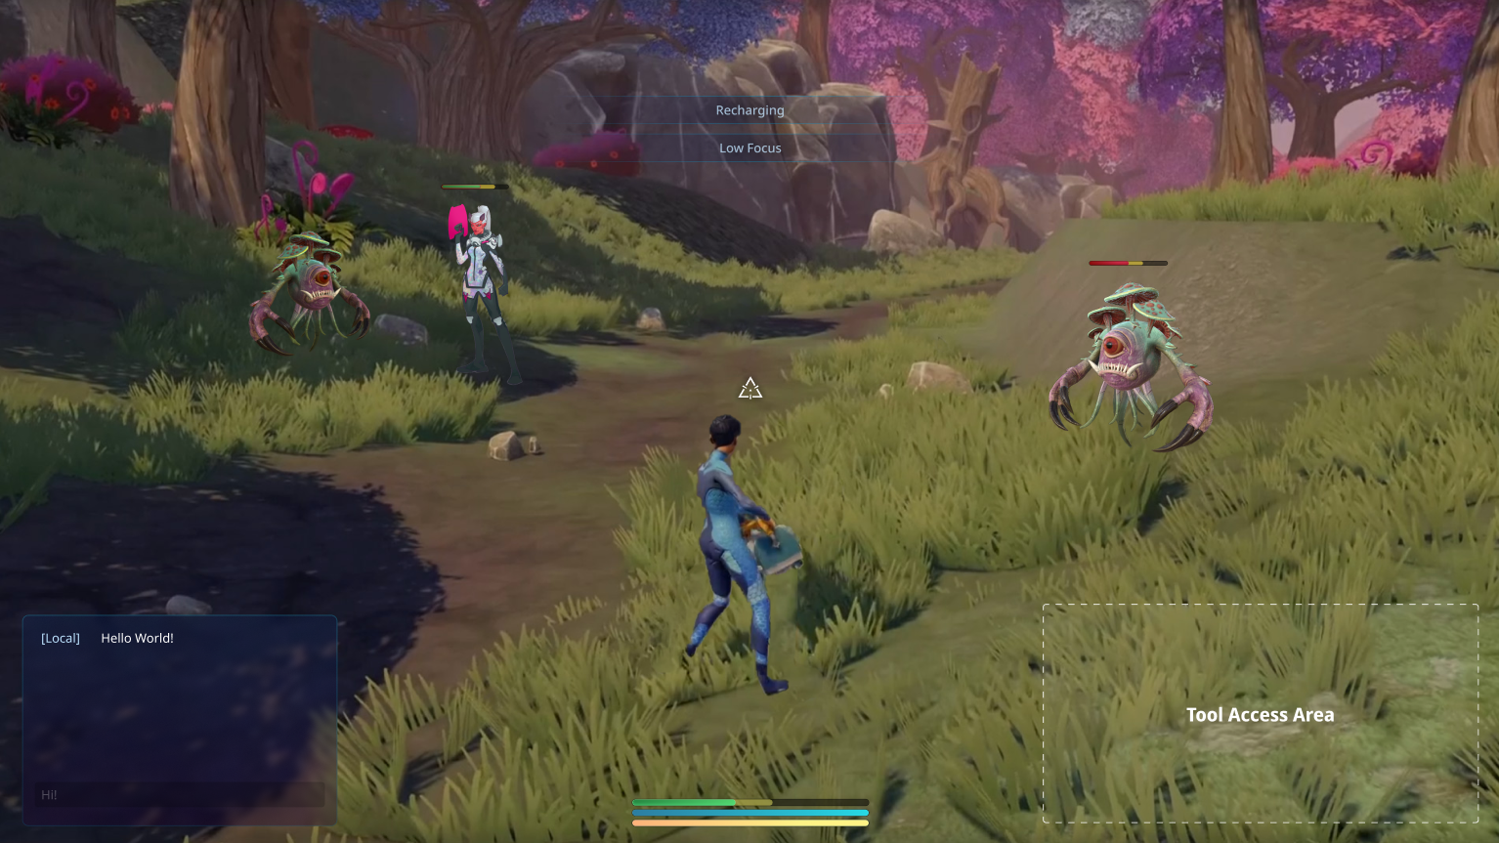

Tool specific UI
- Homing Attack
- Shield

WorldSpace UI
- Creature
  - Health Bar
  - Status Effect (shown by VFX)
- Chat bubbles
- Hit text
- Other players
  - Name Tag
  - Health Bar
- Attack indicator

ScreenSpace UI (HUD)
- Player status area
- Tool access
- Alert
- Reticle
- Chat
- Full-screen effect

Combat Mode

Tool specific UI

Homing Attack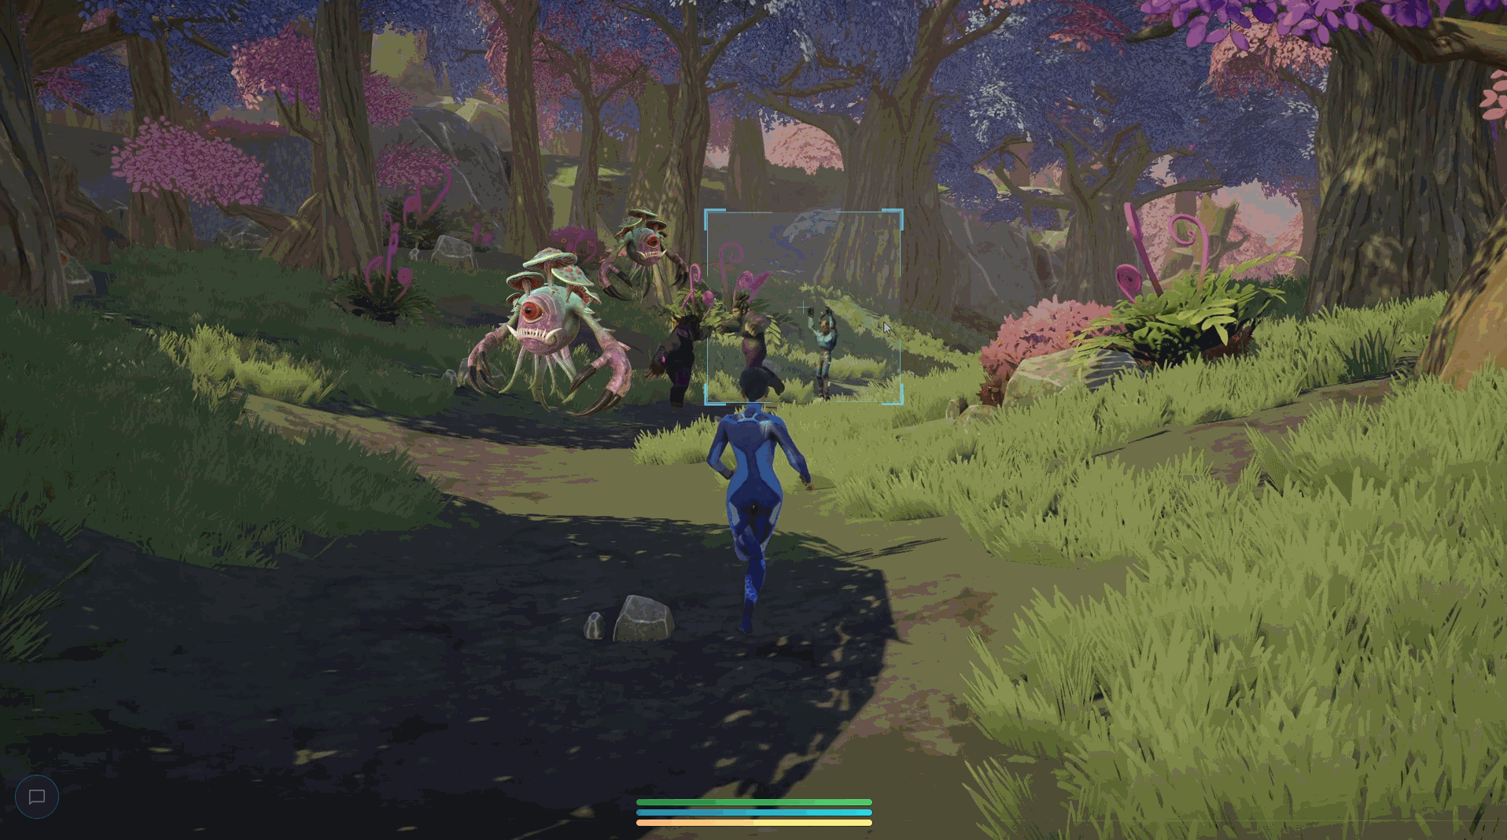
The homing attack UI features a dynamic target zone. The target zone follows as the player adjusts the reticle, highlighting the nearest available target.

Lock a target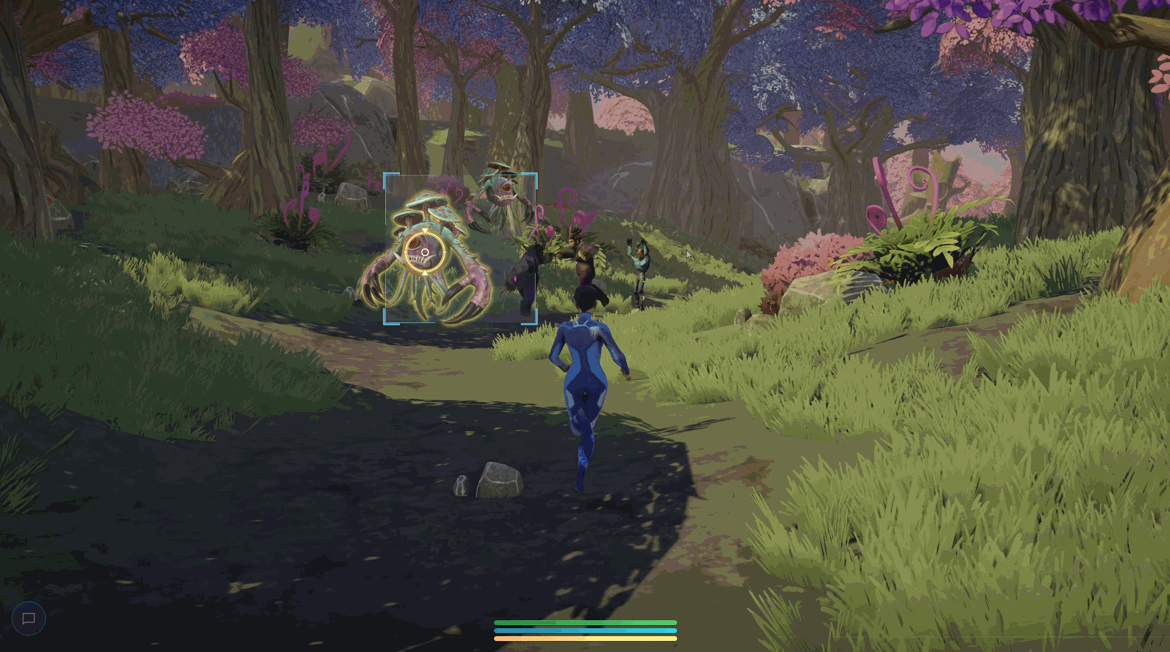
When a target is locked, the target zone shrinks, emphasizing the selected enemy. Once the homing attack is executed or the target becomes unavailable, the target zone expands back to its original size, indicating readiness for another homing attack.
(Red highlight is used here to reinforce the sense of targeting an enemy and aligns with the conventional color scheme used in many games to denote hostile entities. )
Dumb Fire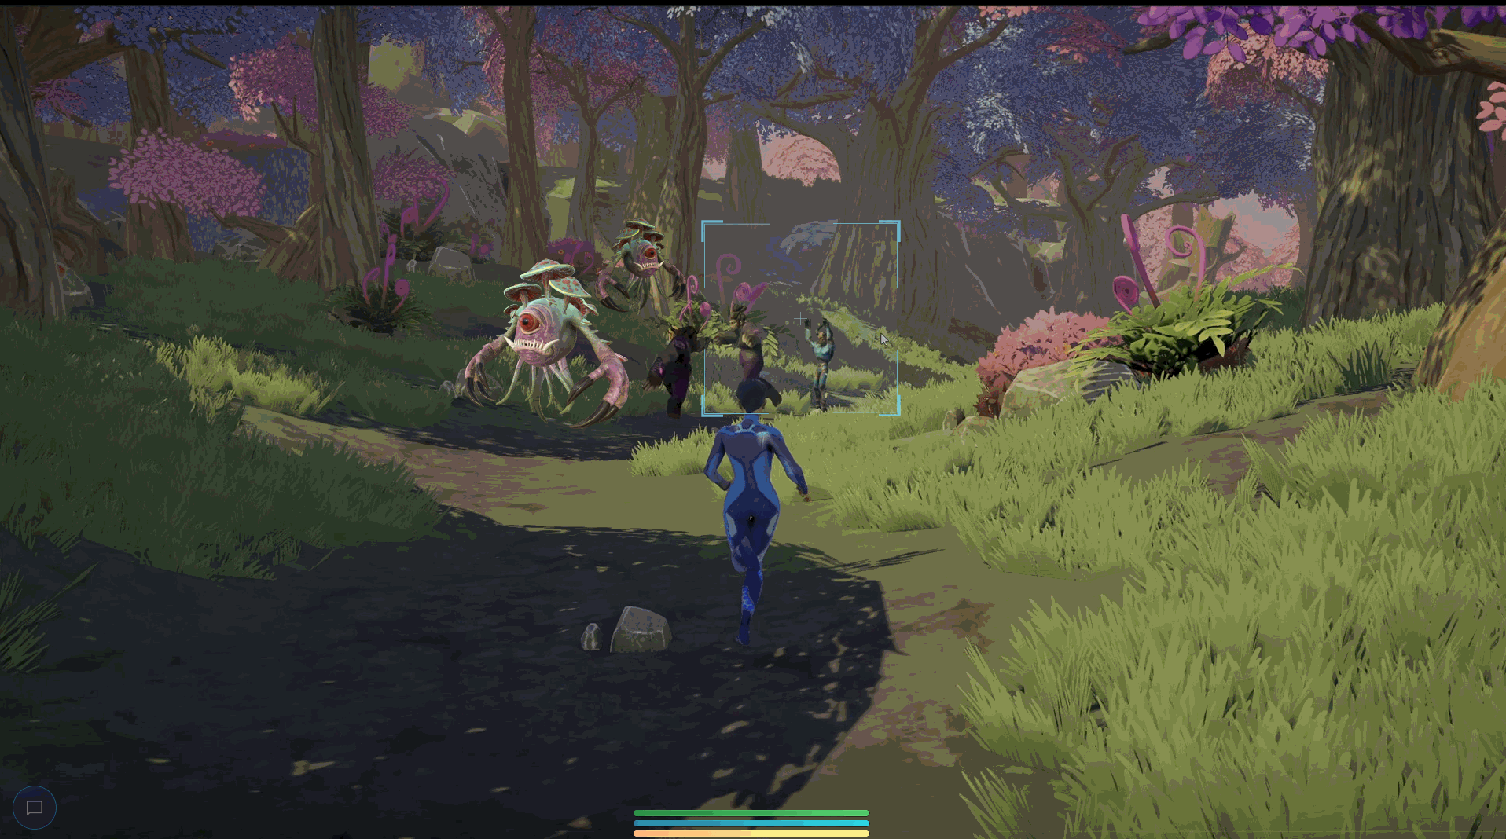

Shield
Display via Health Bar
A white segment of the health bar represents the shield's strength, visually depleting as the shield weakens. This allows for easy monitoring of shield status alongside health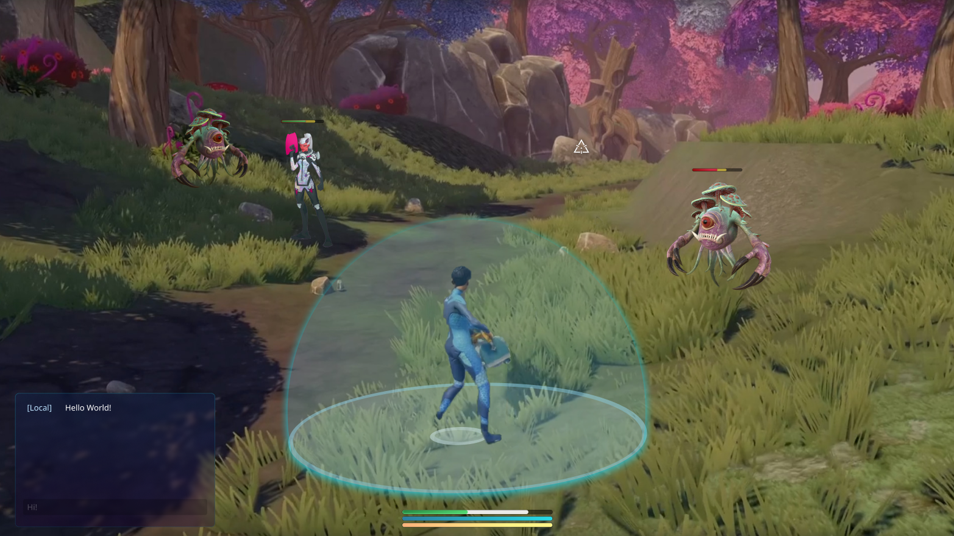
[Alternative options]
the shield capacity can be displayed above the health bar, similar to how status condition icons appear for buffs and debuffs.
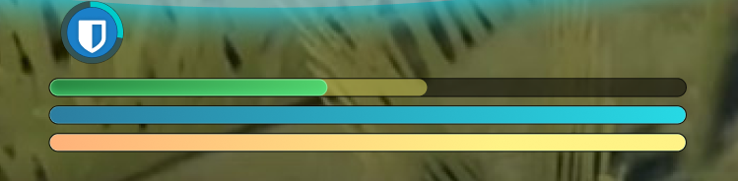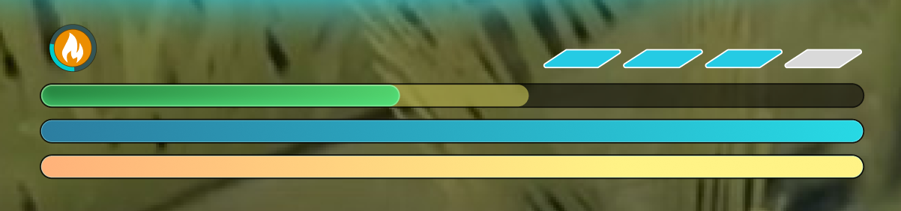

Display near the character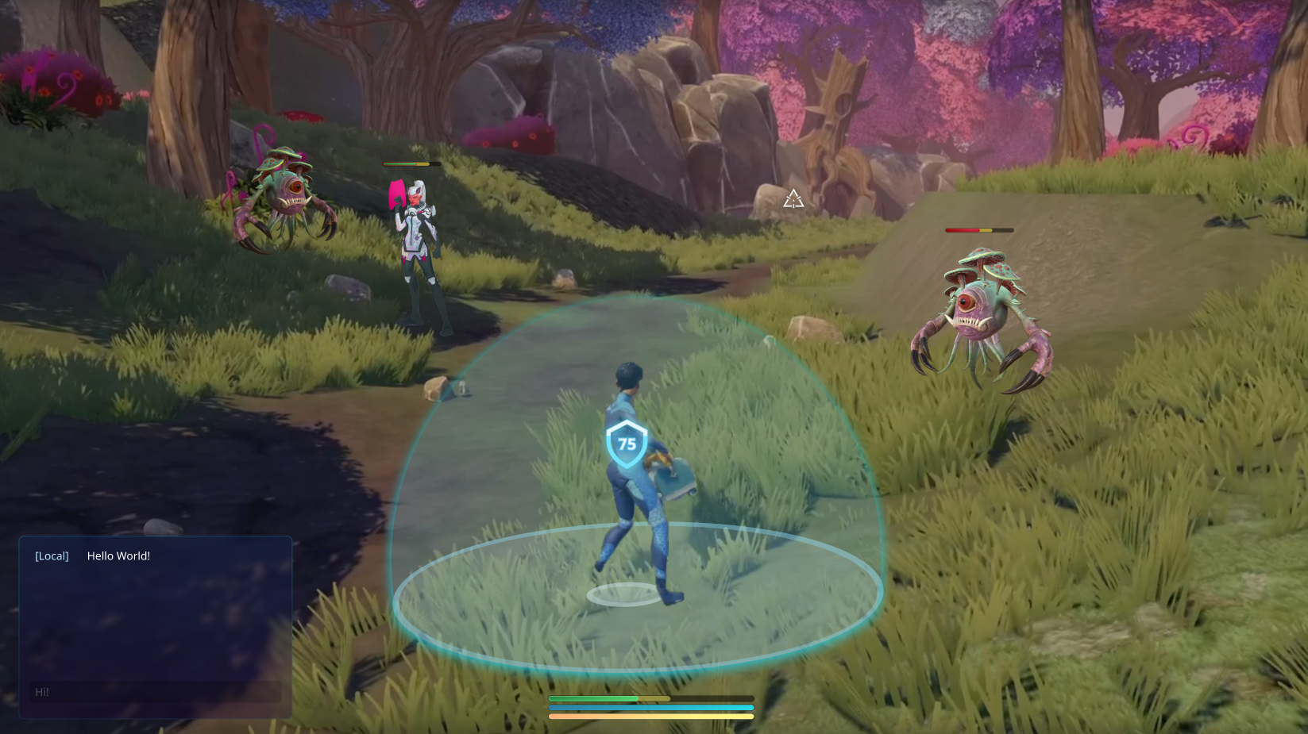
[Alternative options]
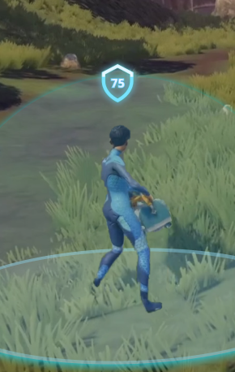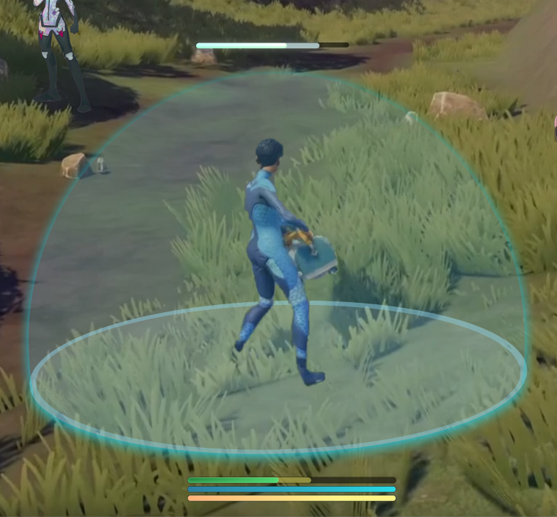
Display on the reticle
Considering the small size of the reticle, it may be challenging to effectively communicate the shield status without visual clutter or distraction from targeting. I would suggest using the combination of showing it on the health bar and near the character to provide a larger and more noticeable representation of the shield capacity
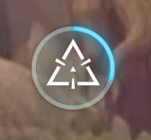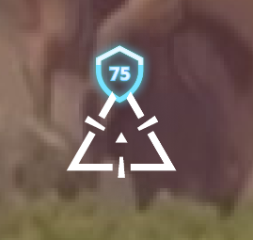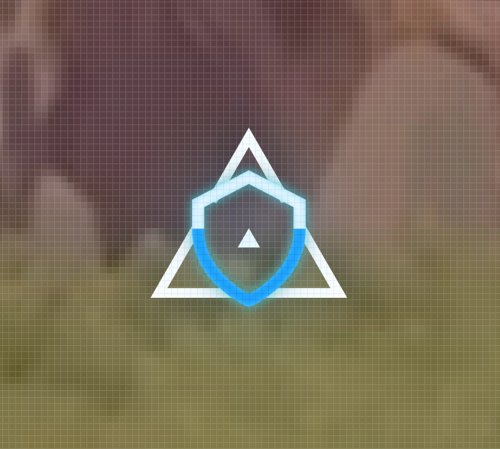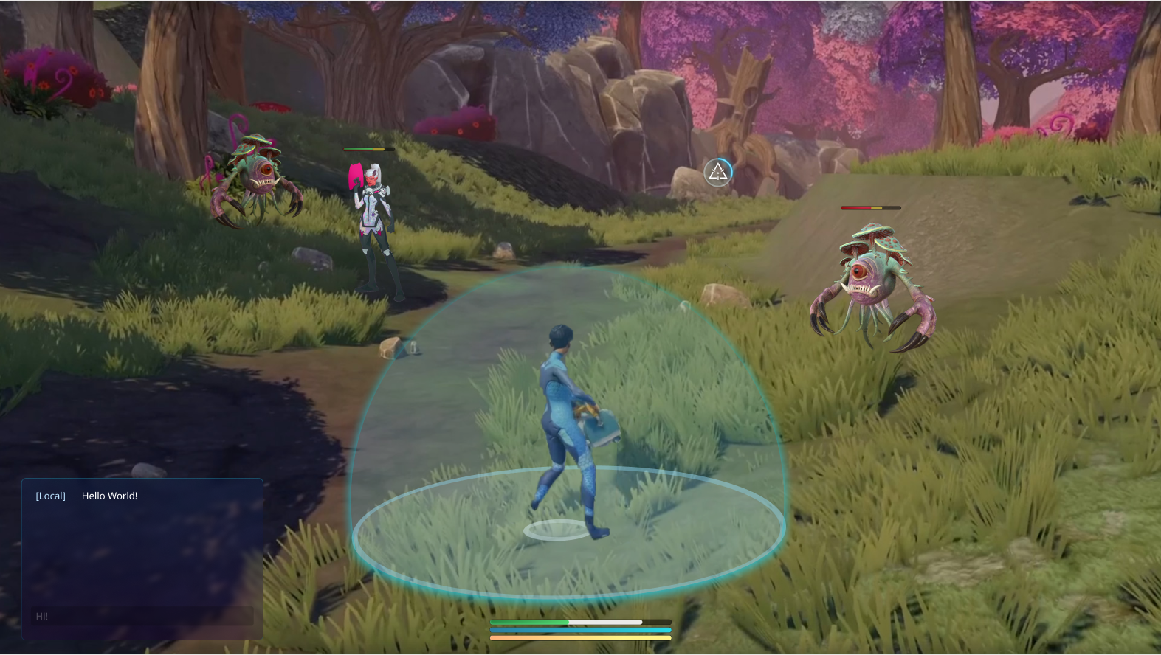

World Space UI

Critter/Other Players Nametag
To maintain a clean and immersive visual experience, it would be beneficial to implement a dynamic nametag display, where nametags are shown only when players are in proximity or during aiming. This approach ensures that the nametags do not clutter the overall aesthetic of the game.
Ideally, designers would be able to adjust the proximity distance to find the most suitable distance.

Hit text
Text size varies based on the level of damage. It is necessary to incorporate animations, sound effects, and VFX to enhance the messaging related to the damage.
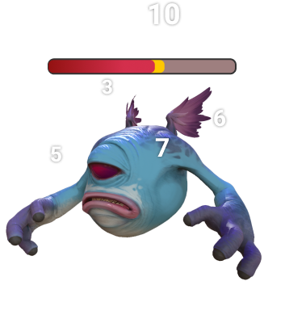

Emoji/Chat Bubbles

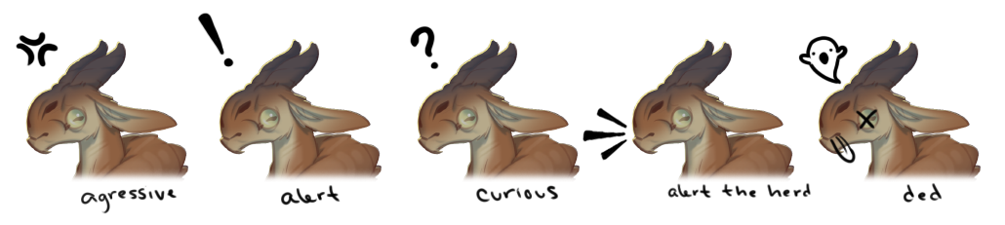

Attack/projectile trajectory indicators
We want to provide some visual cues for the upcoming attacks from enemies to warn players, allowing them to react and avoid or mitigate the incoming damage. This includes colored telegraph lines or shapes on the ground, glowing areas, or distinct animations highlighting the impending attack.
Additionaly, we may have some indicator assists players in predicting the path their projectiles will follow after being fired. It helps them estimate where their attacks will land
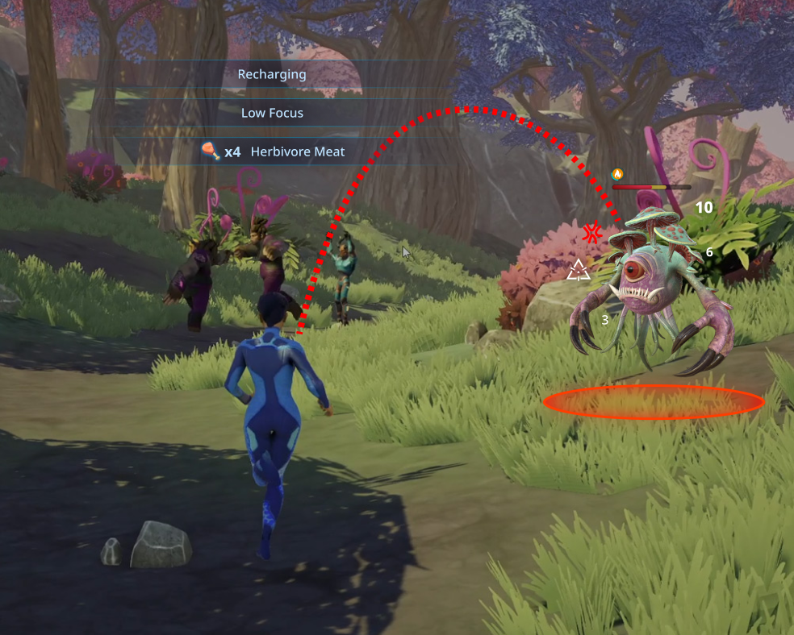

ScreenSpace UI (HUD)

Player status
Appears when a player enters combat mode, begins to deplete one of the status bars, or is in the process of regenerating the status bars. Once combat mode is exited, or the bars are full, the bars will be hidden from the UI.

- Health/Focus/Stamina Bar
- Status conditions/ Dots

Status conditions/ Dots
The icons above the health bar represent the current effects on the player. Any long-lasting effects or status conditions will be communicated using the same method. The icon corresponds to the type of power or status effect applied, and a progress bar around it shows how much time the effect will last.

If there are multiple overlapping instances of the same status effect, the representation will be consolidated. For example, if there are three different heat-based status, they will be combined into a single icon.
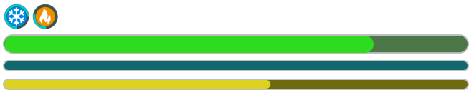

Disorient |  | Radiation |  | Heat | 
Slow |  | shock |  | Cold | 
Brain Control |  | Corrosive |  | Healing | 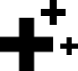
Root |  | Kinetic |  | Icon with  timer | 

Tool access (TBD)
Need to have a way to show ability cooldowns

Alert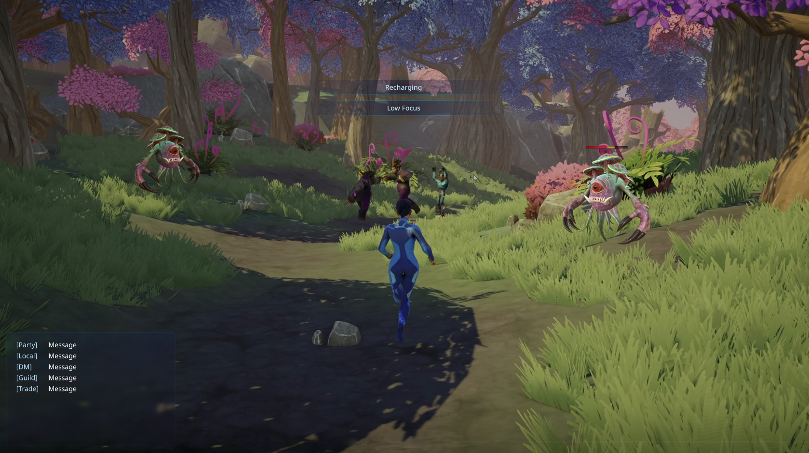
Text alert will stay on the screen for a few seconds and then fade out. Multiple notifications can stack, with the most recent message taking the center stage and pushing the older ones upwards. It is suggested to have a duration of 4 seconds, with a maximum of 8 seconds. These notifications are triggered when the player's focus is depleted, stamina is depleted

Reticle

Chat

Combat Mode
When players encounter hostile enemies or creatures or choose to engage in combat, they will enter combat mode. During combat mode, some UI elements will always show on the screen, BGM changes to Combat tone, and status regeneration speed changes.

 | Default Mode | Combat Mode
HUD Display
Health Bar | When not Full/Under effect | Always
Focus Bar | When not Full/Under effect | Always
Stamina Bar | When not Full/Under effect | Always
Tool Access | When unholstering weapons/tools | Always
Reticle | Always | Always
Status Condition | When has status condition | Always
General
Background Music | Ambient BGM | Combat BGM
Status Regeneration Speed | Normal | Slower
Interaction Restriction | None | None
Movement Restriction | None | None

Players enter combat mode when they meet ANY of the conditions:
- Become the target of enemies.
- Fire weapons/grenades and cause damage to other players or creatures.
- Take damage from enemies’ attacks.

Players leave combat mode when they meet ALL the conditions:
- No longer an enemy target.
- Stop dealing damage to enemies for a few seconds.
- Receive no enemy damage for a few seconds.

Additionally, players will leave combat mode immediately when all enemies are dead.

Sign-off - READY FOR APPROVAL

Final Approval  (right-click to check) | Approver | Date
 | PRODUCT OWNER/GAME DIRECTOR (David Georgeson) | 06/30/23
 | TECH (Avi Khetarpal) | 06/30/23
 | Art (Valerie Zaroli) | 06/30/23
 | UX/UI (Yvette Han) | Jul 5, 2023
 | DESIGN (Light Bates) | 06/30/2023
 | QA Lead (Hayley Ancona) | 06/30/23
 | PRODUCTION (Aiden Wallace) | 06/30/2023
 | MARKETING (Rick Reynolds) | 07/05/2023
 | Lead Producer (Liam Hislop) | 6/30/2023
 | EP (Gordon Walton) | 06/30/2023
 | EXEC/CCO (Raph Koster) | 06/30/23

